For DET: Based, but adapted from, <https://utas.shorthandstories.com/2025_S1_UPP014_06_1lrdt/index.html>

**Welcome to Module 6**

What you will learn:

* The role of integrated sources in your writing.
* How to integrate sources into academic writing.
* How to apply APA style referencing for in-text citations.
* How to establish an APA style reference list.

**Learning Outcomes addressed:**

* **ILO2:** Communicate using academic conventions.
* **ILO3:** Evaluate and integrate academic sources.

**Links to Assessment:**

This module’s content, readings, and discussion directly supports **Assessment Task 2 (AT2): Writing Journal.**The Writing Journal will consist of **3** paragraphs of writing. You will be assessed on the following criteria:

1. Use evidence to support analysis (ILO 3)
2. Communicate with formal, academic language (ILO2)
3. Acknowledge sources using academic referencing conventions (ILO 2, ILO3)

If you are attending a workshop face to face or online, you will be discussing and completing discussion boards and writing drafts in class. If you are studying online, please work through these activities and post in MyLO to gain feedback.

**The role of a source in your writing**

Importantly, critically reading sources provides you with information on the topic you are studying, as well as the ability to form ideas and arguments in response to questions you are asked to answer in the form of essays or reports. Furthermore, to effectively incorporate a source into your paper, it is important to integrate it in such a manner that clarifies for your readers both the origin of the ideas and their contribution to your own analysis. Each source used should serve a deliberate purpose, and the reasoning behind its use should be apparent to the reader. Upon completing your draft, revisit your source integration to ensure each is used intentionally and its purpose is clear.

The role of sources varies, serving as primary evidence, context, theoretical frameworks, or supporting arguments. Consider the role each source played in shaping your perspective on the topic as you draft your paragraphs. Whether providing context, evidence, counterarguments, or complicating your argument, sources should be utilised to support and enrich your analysis. Be aware that a single source may fulfill multiple roles within your purpose.

**Integrating sources into writing**

Integrating a source is using another author’s writing to establish or support your argument. Introducing another author’s work can provide an authoritative voice, introduce a supportive or contrasting position, provide evidence for your own position or make a distinction between different authors’ views (University of New South Wales, 2019).

There are **four methods** to integrate sources into your writing:

**[Direct] Quote**: this is when you use the exact wording from another source. The wording must be *identical* (Morley-Warner, 2009). You should be **selective** when using quotes, choose only a few lines which emphasise or strongly support your point. Have a good reason for using a quote. ***They need to be used sparingly****.* At university, we’re more interested in your understanding that is demonstrated through paraphrasing, summarising, and synthesising. Always include **page numbers** when citing a quotation and enclose the quote in “double quotation marks”. Be sure to introduce the quote, quote it (with citation), and then explain it afterward. We call this “sandwiching”. If you place a quote in the middle of a paragraph without introducing or explaining it, this is called a “hanging” or “dangling” quote and can be confusing for your reader.

**Paraphrase**: is when you convert a passage of another author’s work into your own words (Morley-Warner, 2009). It involves rephrasing the passage of text but not shortening it. Paraphrasing is useful when a quotation would disrupt the flow or tone of your writing.

**Summarise**: is when you filter a passage of another author’s work into the *essential*points (Morley-Warner, 2009). This is useful when you have several sources to include, or the concept is large and needs drilling down to main points. This technique helps you save word count if you have a large amount of information but limited words in which to make your point. A summary will usually take a broader overview of the source.

**Synthesise:** A fourth method is **synthesising** which combines ideas from two or more sources to group or chunk common ideas or positions on a topic. The aim, as you move through UPP, is to practice more synthesising than the other three forms of source integration.

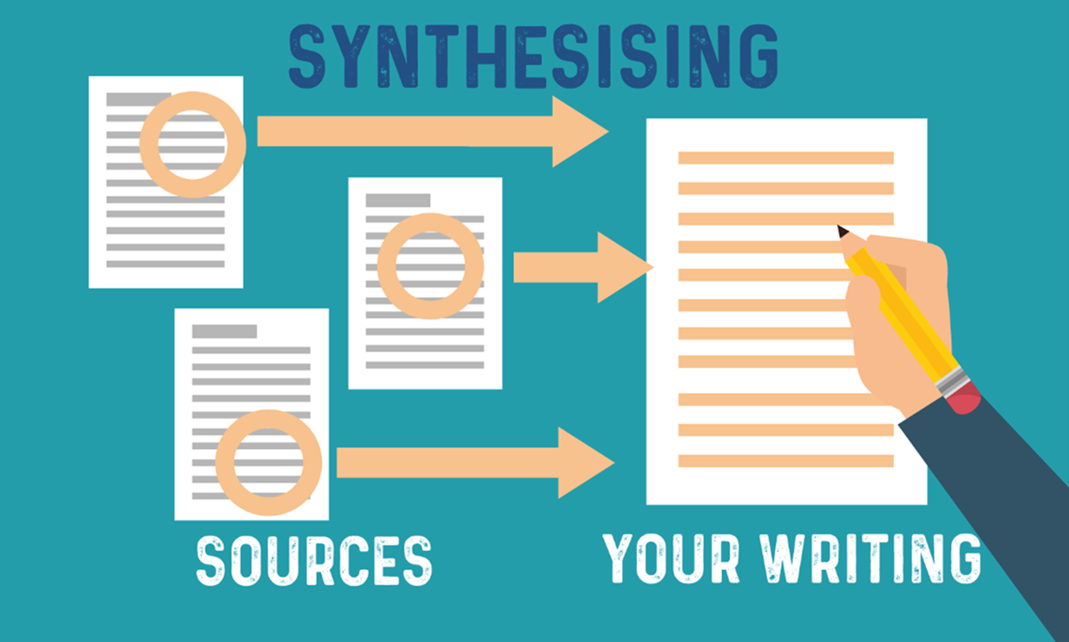

Images courtesy of Amerikanos 2022

**All**forms need to be acknowledged with an in-text citation and a reference of the source in your reference list. Please refer to the [**APA Style Guide**](https://utas.libguides.com/referencing/APA7th) on the UTAS Library website for further assistance on how to cite and reference sources accurately.

**Example**

Here is a paragraph with various in-text referencing used, click on the highlighted section for further information about the type of integration used.

*The Universities Accord final report underscores an urgent need for reforms to accommodate a projected doubling of university enrolments by 2050, aiming to include more students from underrepresented backgrounds. A significant barrier to achieving these enrolment goals is the pervasive feeling of non-belonging among current students, with nearly 50% feeling disconnected from their university community (Crawford, 2024). Research, including the 2022 national student experience survey, reveals that only about half of the students feel a sense of belonging, highlighting the scale of the issue (The Australian Government Department of Education, 2024, as cited in Crawford, 2024). This data signals a deeper systemic issue within universities, where the shift towards online learning and the diminishing campus life are contributing to a crisis in student engagement and well-being. While online education offers flexibility and accessibility, it challenges traditional modes of building community and connection among students. Studies utilising machine learning to analyse student surveys have identified on-campus vs. online study modes as a significant factor affecting students' sense of belonging, with online students feeling less connected (Crawford, 2024). The pivot to online learning, exacerbated by the pandemic, presents a paradox of increasing access to education while potentially undermining the communal and supportive aspects of university life. Addressing this issue requires innovative strategies beyond traditional in-person interactions, including virtual peer-to-peer engagements, mentoring programs, and creating collaborative online learning environments.*

**Different examples of using “in-text” referencing (citations):**

Did you see the following in-text referencing strategies in the excerpt above? Look at some other examples broken down:

**i. Integrating a direct quote**

On brainstorming, it is said one should “Think of a storm: thousands of drops of rain, all coming down together” (Zemach & Rumisek, 2003, p.6).

**ii. Paraphrasing**

The practice of brainstorming can be compared to a heavy storm with lots of raindrops pouring down (Zemach & Rumisek, 2003, p. 6).

**iii. Paraphrasing with source’s voice**

Zemach and Rumisek (2003, p. 6) compare the practice of brainstorming to a heavy storm with lots of raindrops pouring down.

**iv. Direct quote with source’s voice**

On brainstorming, Zemach & Rumisek (2003, p.6) state, “[t]hink of a storm: thousands of drops of rain, all coming down together”.

**Referencing**

Core to academic writing and maintaining [**academic integrity**](https://utas.shorthandstories.com/academic_integrity/index.html) is the convention of referencing. References are integral to academic writing for a few reasons:

1. As part of evidence of research/quality assurance (support material, using evidence)
2. Showing knowledge and recognition of literature on topic (discussion of ideas in a community, methodology).
3. For academic integrity purposes (avoiding plagiarism)

**So, *when*do you reference?**

You must provide a reference whenever you: **quote**, **paraphrase**, or **summarise *someone*else’s**ideas, theories, or data.

You must also reference any graphic information you use such as **pictures**, **graphs**, or **tables**. You learn to reference graphs and tables in UPP015 Numeracy and Data.

***You should think of referencing whenever you mention any kind of source, not just books or articles, but it could be a radio interview, a film, or even a computer game!***

In UPP014, we ask students to use the **APA style of referencing.**

APA is a referencing method developed by the *American Psychological Association*(APA stands for*American Psychological Association)* and is a version of the commonly used **Author-Date system.**Being an author-date system, it requires two things:

* 1. References need to be in the text **(“in-text citations”)**,

AND

* 1. References need to be in a list at the end on an essay/assignment **(“Reference List”)**

[**Click the link**](https://utas.libguides.com/referencing/APA7th) and watch the embedded video ‘Fundamentals of APA’ from UTAS Library Services.

**The Reference List**

All reference list entries are double-spaced and are formatted with a hanging indent. Reference list entries include the four elements of the author, date, title, and source. The heading, **References**, on a new page straight after your writing, is centred and bold.

**Author(s):**

The *author* refers broadly to the person(s) or group(s) responsible for a work. An author can be an individual, a group of people, a group such as an institution, government agency, or organisation, or a combination of people and groups (American Psychological Association, n.d.).

Please see the table below that illustrates author types and the referencing structure.

|  |  |  |  |
| --- | --- | --- | --- |
| **Author Type** | **Structure** | **Example in-text** | **Example Reference** |
| An individual | Surname, first initial. | (Smith, 2025) | Smith, J. (2025) ... |
| Multiple people | Surname, initial., & Surname, initial. | (Smith & Jones, 2025) | Smith, J., & Jones, S. (2025) … |
| A group (institution, government agency, organisation). | Organisation. | (World Health Organisation, 2025) | World Health Organisation. (2025) ... |
| A combination of people or groups. | Group name, & Surname, initial. | (World Health Organisation & Smith, 2025) | World Health Organisation, & Smith, J. (2025) … |

**Dates:**

The date refers to the **year** the source was published. Use the year for most works (e.g., journal article, book). Put the year in brackets. End with a period.

Use a more specific date (e.g., year and month or year, month, and day) for digital works published on a regular basis such as a website. Write the year, a comma, and the specific date. Write out month names in full. Put the date in brackets. End with a full stop.

**No date:** If there is no date for the work, write “n.d.” in brackets.

Please see the table below that illustrates source types and the referencing structure for dates.

|  |  |  |  |
| --- | --- | --- | --- |
| **Source Type** | **Structure** | **Example in-text** | **Example Reference** |
| Journal article, book, film | (YEAR) | (Smith, 2025) | Smith, J. (2025) ... |
| Websites, webpages, YouTube videos, regularly published/updated digital resources. | (YEAR, Month, Day) | (2025**,**July 6). | Smith, J. (2021**,**July 6)**.** |
| No date. | n.d. | (World Health Organisation, n.d.) | World Health Organisation. (n.d.) ... |

**Titles**

The title is the name of the source being cited, usually presented as a heading. Complete works or works that stand alone (for example, book, report, film, social media post, webpage), italicise the title, and capitalise it using sentence case (only the first word or words after a colon are capitalised).

For **books and reports**, enclose any identifying information (For example, edition, volume, report number) in brackets after the title. Put a full stop after, but not before, the bracketed information. Do not italicise the full stop or bracketed information.

For **videos**, add a description of the work in square brackets after the title (before the period) if helpful in identifying it (such as a video or video game) and place it after any bracketed information.

Please see the table below that illustrates source types and the referencing structure for titles.

|  |  |  |
| --- | --- | --- |
| **Source Type** | **Structure of title** | **Example Reference** |
| Books & Reports | Italicise the title. Use *sentence case* (capitalise only the first word, subtitle, and proper nouns). | Mackinlay, E., & Madden, K. (Eds.). (2024). *Departing radically in academic writing: Alternative approaches to writing and methods in qualitative research* (First edition.). Routledge. |
| Book Chapters | Chapter title is *not* italicised. Book title is italicised. | Brett, P., & Zarmati, L. (2024). Learning history. In L. Tudball, P. Brett, & R. Gilbert (Eds.), *Teaching humanities and social sciences: Teaching and learning across Australia* (pp. 252-279). Cengage. |
| Journal Articles | Title is *not* italicised and written in *sentence case*. Capitalise only first word, subtitle, and proper nouns. | Kim, J., Yu, S., Detrick, R., & Li, N. (2025). Exploring students’ perspectives on Generative AI-assisted academic writing. *Education and Information Technologies*, *30*(1), 1265–1300. <https://doi.org/10.1007/s10639-024-12878-7> |
| Webpages | Italicise the webpage title in *sentence case*. | Alberro, H. (2022). *Climate change: radical activists benefit social movements – history shows why.* The Conversation. <https://theconversation.com/climate-change-radical-activists-benefit-social-movements-history-shows-why-181977> |

**Source - Publishers:**

Sources that stand alone (For example, report, film, social media post, webpage), the source is the ***publisher*** of the work, database or archive, social media site, or website, plus any DOI or URL.

Sources that are part of a greater whole (for example, journal **article**, edited book **chapter**, TV **episode**), the **source** is the greater whole (for example, journal, book, TV show), plus any DOI or URL.

Journals and periodicals (For examples magazines or newspapers), the volume number of a journal article is included in *italics* and the issue number the journal article features in is bracketed and **not** italicised. Separate the page numbers by an en dash and follow with a full stop. End with any DOI written as a hyperlink in the format: https:// doi.org/xxxxx

For books and reports, write the publisher’s name as shown on the work and without italics, followed by a period. A publisher, particularly for reports, can be a government agency. Books and ebooks are formatted the same.

For an edited book, write the word “In” followed by the initials and surnames (not inverted) of the editor(s), followed by “(Ed.).” for one editor and “(Eds.).” for two or more editors. Then put a comma, the title of the book in *italic*sentence case, and the page (abbreviated “p.”) or page range (abbreviated “pp.” and separated by an en dash) of the chapter. Follow with a full stop. End with any DOI or URL.

For webpages, provide the website name in title case without *italics*. When the author is the same as the website name, omit the website name from the source. End with the URL. In most cases, **do not**include a retrieval date unless there is date of publication on the webpage.

|  |  |  |
| --- | --- | --- |
| **Publisher Type** | **Structure** | **Example Reference** |
| Sources that stand alone (e.g., TV series, film, social media post,) | Publisher name. DOI or URL if digital. | *Imagine Entertainment.* *Instagram.* <https://www.instagram.com/p/CGDaLBKplB-/> |
| Books | Publisher name as shown on the work, not italicised. Government agencies can be publishers. End with URL if available. | Cengage.  The Guilford Press.  Oxford University Press.  Tudball, L., Brett, P., & Gilbert, R. (2024). *Teaching humanities and social sciences: Teaching and learning across Australia*. Cengage. |
| Edited book chapter | Write “In” + editors’ initials and surnames + (Ed.) or (Eds.).  Publisher name as shown on the work, not italicised. | Brett, P., & Zarmati, L. (2024). Learning history. In L. Tudball, P. Brett, & R. Gilbert (Eds.), *Teaching humanities and social sciences: Teaching and learning across Australia* (pp. 252-279). Cengage. |
| Reports on websites | Publisher name *not* italicised. May be the same as the author’s (organisation) name. | Australian Institute of Health and Welfare. (2024). *Australia’s health 2024: In brief*. Australian Institute of Health and Welfare. <https://www.aihw.gov.au/reports/australias-health/australias-health-2024-in-brief/summary> |
| Webpages | Use the website name in Title Case, without italics. | The Conversation.  Alberro, H. (2022). *Climate change: radical activists benefit social movements – history shows why.* The Conversation. <https://theconversation.com/climate-change-radical-activists-benefit-social-movements-history-shows-why-181977> |

**ACTION REQUIRED!**



(Breakingpic, n.d.)

Review your **Module 4** and **Module 5 paragraphs** and consider where you need to include an in-text citation. Insert the in-text citations using the appropriate author details. Your **Module 6 paragraph draft** will need to an attempt at in-text citations so you can receive feedback before submission for assessment.

**Anatomy of a journal article**

You have one more reading to complete for AT2 which can be found on the **Module 6 MyLO page**. This week, we read a peer-reviewed journal article. Download or print the journal article provided.

Here is an image of an example journal article with key features highlighted.

The APA reference for this article is:

Huisman, B., Saab, N., van den Broek, P., & van Driel, J. (2019). The impact of formative peer feedback on higher education students’ academic writing: a Meta-Analysis. *Assessment and Evaluation in Higher Education*, *44*(6), 863–880. <https://doi.org/10.1080/02602938.2018.1545896>

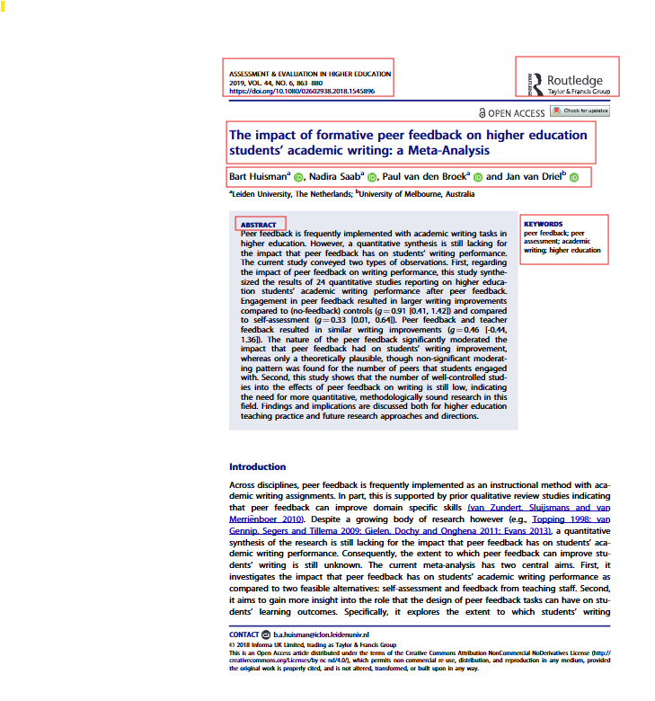

Beyond the first page of a journal article are a range of sections, usually separated by headings. We’ve provided a table of general features commonly found in peer-reviewed journal articles.

| **Feature** | **Where to Find It** | **Why It Matters** |
| --- | --- | --- |
| **Journal Name & Details** | Top of the page (e.g., *Assessment & Evaluation in Higher Education, 2019, Vol. 44, No. 6, 863–880*) | Helps identify the source, volume, issue, and page numbers for referencing. |
| **DOI (Digital Object Identifier)** | Under the journal name, near the top | Provides a permanent link to the article — essential for APA referencing. |
| **Article Title** | Bolded in large font (e.g., *The impact of formative peer feedback on higher education students’ academic writing: A Meta-Analysis*) | States the focus of the article. |
| **Authors & Affiliations** | Beneath the title (often with links to author bios or academic profiles). | Shows who wrote the article and their institutional connections. Useful for understanding authority (expertise) and any potential biases of authors. |
| **Abstract** | Usually boxed or in a separate section on the first page | Provides a summary of the research aims, methods, and findings — the “snapshot” you can read to decide if it’s relevant for your topic. |
| **Keywords** | Next to or below the abstract (e.g., peer feedback, academic writing, higher education) | Helps with database searching and finding related articles. |
| **Introduction** | Starts with background context Often features a title: Introduction. | Explains the research problem, rationale, and literature on which the authors have based context (the background reading they’ve done). |
| **Main Body (Methods, Results, Discussion)** | Follows the introduction, usually these sections will have subheadings. | Details how the research was done, what was found, and why it matters. |
| **References** | End of the article | Shows the sources used — shows credibility and transparency. A great place to find more readings. |
| **Author Contact Info / Notes** | Often at the bottom of the first page | Provides correspondence details and copyright info. |

**Reading reminders**

We’d like to remind you of the **Module 1** discussion on reading and notetaking, as part of the writing process and the **Module 5** discussion about critical reading and writing.

Critical reading requires an active approach such as making annotations or notes as you read and thinking deeply about the information presented (Greetham, 2013, p.86). To help with critical reading, there are strategies which can support time-management and efficient location of relevant information.

Greetham (2013) recommends two key strategies:

* **Skimming**: looking at the broad structure of the text by looking at how paragraphs and sections are formatted, gaining a general impression of its nature and purpose by examining **headings** and **subheadings**, and picking up the key ideas. Often skimming the **abstract** of an article (the summary at the beginning of the text; it is like the academic version of a book blurb) is helpful to identify the text’s content. Skimming is often used to determine the text’s suitability and whether we should be ‘going further’ by reading more thoroughly. You can also read the **topic** and **concluding** sentences of paragraphs, as we know from **Module 4**, that these sentences contain the key or core ideas of the paragraph.
* **Scanning**: looking for an answer to a specific question. Scanning involves looking for specific terms or phrases, data tables or other figures, other authors cited, or a specific point to support your writing. Scanning is done with particular purpose. **Hot tip:** A quick way to scan is to use Ctrl-F on your keyboard which will open a search tab for the document you have open – tap in the keyword and it will highlight all occasions of that word and give you a total of how many times that word appears in the document.

Laura Brown (2017) offers some of the following ‘dos’ and ‘don’ts’ when critically reading sources:

|  |  |
| --- | --- |
| **Do** | **Don't** |
| Carefully read the source – and more than once. | Don’t get distracted by words or phrases you don’t know when you’re reading. Make a note to follow up later. But do follow up! |
| Take notes whilst and/or after reading. | Use your own words when notetaking – don’t copy and paste any phrases from the original. |
| Keep your notes brief – you are paraphrasing – not reproducing. | Read without purpose – highlight key phrases and terms – know what you’re reading for. |
| Try to understand how the author has organised their ideas and material – this will make summarising it easier. |  |

**References**

American Psychological Association. (n.d.). *Elements of reference list entries*. APA Style. Retrieved August 18, 2025, from <https://apastyle.apa.org/style-grammar-guidelines/references/elements-list-entry>

Amerikanos, L. (2022). *Direct quote, paraphrasing, summarising, synthesising.* [Image].

Breakingpic. (n.d.). *To do list with scrabble letters and sticky note* [Photograph]. Pexels. <https://images.pexels.com/photos/3299/postit-scrabble-to-do.jpg>

Brown, L. (2014). *How to write anything: A complete guide*. W.W. Norton & Company.

Greetham, B. (2013). *How to write better essays.* 3rd edn, Palgrave.

Morley-Warner, T. (2009). *Academic Writing Is…. A Guide to Writing in a University Context*. Association for Academic Language and Learning.

University of New South Wales. (2019). *Paraphrasing, summarising, and quoting*, UNSW Academic Skills, <[**https://student.unsw.edu.au/paraphrasing-summarising-and-quoting**](https://student.unsw.edu.au/paraphrasing-summarising-and-quoting)>.

Zemach, D.E., & Rumisek, L.A. (2003). *Academic writing: from paragraph to essay*. Macmillan Education.